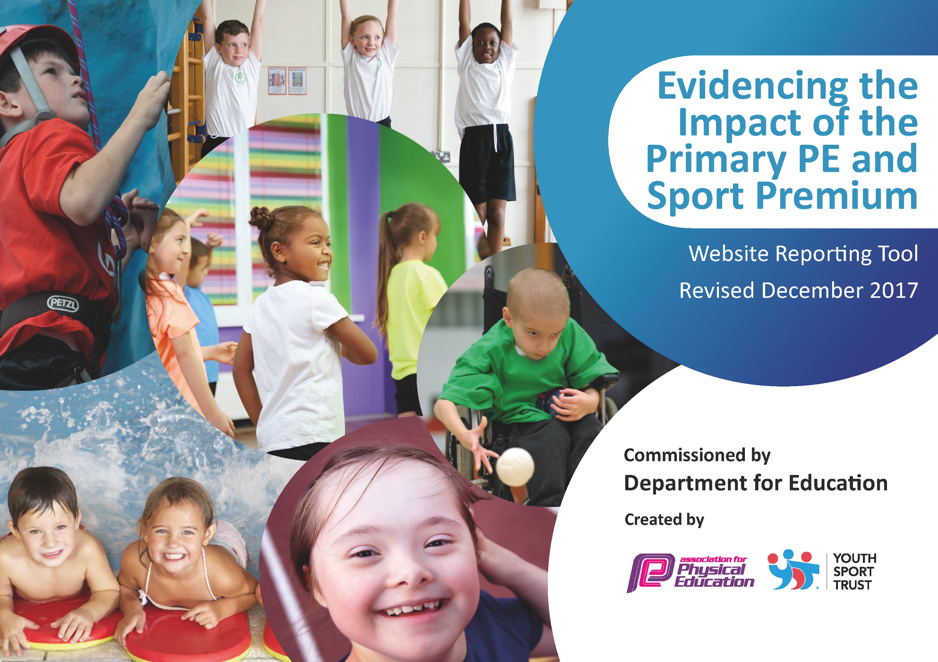



Schools must use the funding to make additional and sustainable improvements to the quality of PE and sport they offer. This means that you should use the Primary PE and Sport Premium to:

- develop or add to the PE and sport activities that your school already offers
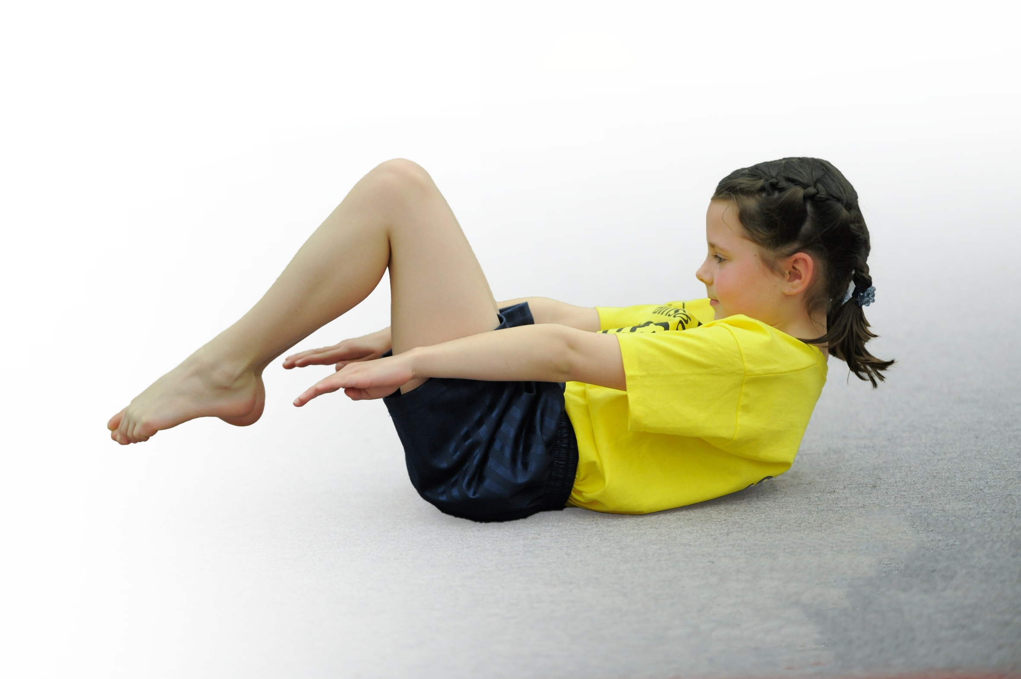
- build capacity and capability within the school to ensure that improvements made now will benefit pupils joining the school in future years

Please visit gov.uk for the revised DfE guidance including the 5 key indicators across which schools should demonstrate an improvement. This document will help you to review your provision and to report your spend. DfE encourages schools to use this template as an effective way of meeting the reporting requirements of the Primary PE and Sport Premium.

We recommend you start by reflecting on the impact of current provision and reviewing the previous spend.
Under the Ofsted Schools Inspection Framework, inspectors will assess how effectively leaders use
the Primary PE and Sport Premium and measure its impact on outcomes for pupils, and how effectively governors hold them to account
for this.

Schools are required to publish details of how they spend this funding as well as on the impact it has on pupils’ PE
and sport participation and attainment.
We recommend regularly updating the table and
publishing it on your website as evidence
of your ongoing review into how you are using the money
to secure maximum, sustainable impact. To see an example of how to complete the table please click HERE.

Support for review and reflection - considering the 5 key indicators from DfE, what development needs are a priority for your setting and
your students now and why? Use the space below to reflect on previous spend, identify current need and priorities for the future.

Keresley Grange and Keresley Newland

Key achievements to date: | Areas for further improvement and baseline evidence of need:
Real PE is now fully operational within school with all teachers having the training and opportunity to observe and take part in showcase lessons.  Whilst competitions haven’t been able to happen in the usual way, due to Covid restrictions, children have taken part in a range of competitive activities throughout the year.  The implementation of Real PE has meant that ALL teachers now deliver high quality, well differentiated PE lessons.  We have begun developing the use of ICT within PE lessons to all for greater differentiation and on the spot assessment opportunities.  Active Playtimes are planned for and resourced with children provided with instruction and time to take part in activities such as skipping, playground games, clapping games, diablos, Frisbee, French skipping, etc. The children have participated well with these and the adults are seeing positive engagement at playtimes. | - Afterschool and lunch time sports provision.  - Continuing to develop the Real Legacy within our school, and review competitive sport.  - Introduce opportunities for children to take part in more physical/outdoor activities that are non-sports based.  - Include opportunities throughout the year for enrichment days  - Top up swimming for those in need.  - Opportunities for competition across both of the Keresley Academies.  - Order and organize new resources to support the delivery of high quality PE lessons.  - Review swimming provision in 2022/23  - Review use of sport coaches in 2022/23  - Continue to develop activity outside of PE and clubs. 2022/23  - Review and develop Activity Passport. 2022/23

 | Meeting national curriculum requirements for swimming and water safety |  |  |  | Please complete all of the below*:
 | What percentage of your current Year 6 cohort swim competently, confidently and proficiently over a distance of at least 25 metres? |  |  |  | 25%*
 | What percentage of your current Year 6 cohort use a range of strokes effectively [for example, front crawl, backstroke and breaststroke]? |  |  |  | 25%*
 | What percentage of your current Year 6 cohort perform safe self-rescue in different water-based situations? |  |  |  | 25%*
 | Schools can choose to use the Primary PE and Sport Premium to provide additional provision for swimming but this must be for activity over and above the national curriculum requirements. Have you used it in this way? |  |  |  | Yes/No
 | What percentage of your current Year 6 cohort swim competently, confidently and proficiently over a distance of at least 25 metres? |  |  |  | 30%
 | What percentage of your current Year 6 cohort use a range of strokes effectively [for example, front crawl, backstroke and breaststroke]? |  |  |  | 30%
 | What percentage of your current Year 6 cohort perform safe self-rescue in different water-based situations? |  |  |  | 30%
 | Schools can choose to use the Primary PE and Sport Premium to provide additional provision for swimming but this must be for activity over and above the national curriculum requirements. Have you used it in this way? |  |  |  | YES
Budget for 2021/22 |  | 16940 | 18500
 |  | KN | KG
Jasmine License |  | 248 | 248
TLR |  | 2000 | 2000
Resources |  | 1300 | 750
Enrichment Opportunities |  | 0 | 0
Swimming |  | 0
Forest School staffing. |  | 4610 | 6915
Forest School Resources |  | 125 | 200
Residential/outdoor education. |  | 1316 | 620
After school clubs. |  | 4868 | 6400
Positive Impact |  | 850 | 0
Active Maths English |  | 1378 | 1378
Total Spent |  | 16695 | 18511
Amount left for 2021/22 |  | 245 | -11

Action Plan and Budget Tracking
Capture your intended annual spend against the 5 key indicators. Clarify the success criteria and evidence of impact that you intend to measure to evaluate for students today and for the future.

Academic Year: 2021/22 | Total fund allocated: £18,510  Rolled over from 2020/21  Total fund allocated: £16940, including roll-over |  |  |  |  | Date Updated: July 2022
Key indicator 1: The engagement of all pupils in regular physical activity – Chief Medical Officer guidelines recommend that primary school children undertake at least 30 minutes of physical activity a day in school
School focus with clarity on intended impact on pupils: |  | Actions to achieve: | Funding allocated: |  | Evidence and impact: | Sustainability and suggested next steps:
Curriculum overview in place to support T&L of PE, developing CPD.  Key Lessons being delivered by teachers or school staff, with integral CPD.  TAs present for CPD.  Sports coaches deliver lessons with TAs present for CPD, coaching. |  | Termly Breakdown of PE/Sport coverage is in place.  Ensure resources are organized and available to support each terms learning.  Staff are coached to develop new skills in teaching PE.  Top up training of Real PE for new staff. | £4050  £2890  Real Legacy Payment |  | Children are achieving ARE for PE.  Teachers and TA have increased PE subject knowledge. | Review curriculum and resources used.
Children’s participation in physical activity cross and beyond the school day including:  - Breaktimes  - Forest Schools and outdoor learning  - Active learning takes place across curriculum – Active Maths and English  - Residential Education – PE focus  Sport is a vehicle for supporting emotional well-being, through positive impact. |  | Active playtimes – planned for with resources in place to support engagement  Trained staff, teach groups of children.  Resources and CPD for Maths and English.  PGL for Y5-6  Book positive impact.  Identify key children  Evaluate | £750 (shared cost across both sites)  £7115 - FS  £4735  £1316 – PGL  £620  £1378 - AcM/E  £1378  £6400 – Coach and Clubs  £4868  £850 |  | All children access active playtimes and choose active activities.  Soft data – staff and children enjoy sessions.  Children use activity for emotional regulation. | CPD for DRAs and lunchtime staff.  Sport coaches.  Sports Leaders – Y5-6  Positive Impact across both schools.
Key indicator 2: The profile of PE and sport being raised across the school as a tool for whole school improvement

School focus with clarity on intended impact on pupils: |  | Actions to achieve: | Funding allocated: |  | Evidence and impact: | Sustainability and suggested next steps:
PE Lead in place to raise the profile and implement changes in school. |  | PE Lead to manage and support PE and Sport within school.  Review REAL PE for impact.  Expert of the Week focus on sport. | Sports’ Leadership  £2000  £2000 |  | PE lead left mid-year.  New lead and CPD in school with coach. | Developed in future years.  New lead 2022-23  Develop Sports Leads for Y5-6
Intra School Competitions planned throughout the year. |  | Competition Timetable in place. | Resources for competitions if needed.  Certificates for participation. |  | Only one competition attended – Girls’ Football.  Meeting with coaches to secure for following year. | 2022/23
Sports News to be included within the whole school newsletter. |  | Parents and stakeholders will be more aware of what is going on with PE and sport within school on a fortnightly basis. | Time  Newsletter |  | Higher profile of PE and sport. | Continue, with a focus on competitive sport.

Key indicator 3: Increased confidence, knowledge and skills of all staff in teaching PE and sport
School focus with clarity on intended  impact on pupils: | Actions to achieve: | Funding  allocated: | Evidence and impact: | Sustainability and suggested  next steps:
Staff work alongside expert coaches to deliver PE, developing knowledge. | PE coach secured.  Identify staff to support. | £6400 – Coach and Clubs  £4868 | Staff have strong subject knowledge and deliver high quality lessons. | Continue, with review for plan for learning.

Key indicator 4: Broader experience of a range of sports and activities offered to all pupils
School focus with clarity on intended  impact on pupils: | Actions to achieve: | Funding  allocated: | Evidence and impact: | Sustainability and suggested  next steps:
Curriculum Map to support the use of a variety of sports throughout the school year. | Create a curriculum map for the whole school. Review at the end of the year.  Develop alongside Activity Passport, Wider Opportunities.  Children watch a range of sports that are unusual for inspiration. |  | Children participating in an increasing range of sports throughout the year with progression in place for our Year A and Incudes – PE, Clubs and Enrichment. | Review in 2022/23
Key indicator 5: Increased participation in competitive sport
School focus with clarity on intended  impact on pupils: | Actions to achieve: | Funding  allocated: | Evidence and impact: | Sustainability and suggested  next steps:
Membership into the BPSSA and ESFA for access to competitions in a range of sports  Partner school membership with CV Life (Use of the AT7) | Arrange a Festival for specific year groups using the AT7 Venue. | £400 SGO | Limited as competitions not secured.  Plan in place for 2022/23 | Reinstate the competition calendar to allow children to participate in competitive sport throughout the year. 2022/23
/

